Running the Application

Build the Visual Studio Solution

Build the solution Keebee.AAT.sln in both Debug and Release mode.

Create Web Applications

1. Create the folder structure “C:\Deployments\Web\Data\1.0.0.0”
2. In the new folder copy/paste the folder **Keebee.AAT.DataAccess** (from the code repository)
3. Create the folder structure “C:\Deployments\Web\API\1.0.0.0”
4. In the new folder copy/paste **Keebee.AAT.Operations** (from the code repository)
5. Go to the properties for the folder “Keebee” (created in step 1) click the Security tab, then “Edit”, then “Add” to add the user “EVERYONE” to have access to the folder (default permissions are sufficient)
6. Open *Internet Information Services Manager* and add a new application by expanding *Sites* and right-clicking on *Default Web Site*
7. For the *Alias*, type **Keebee.AAT.DataAccess** and assign the *Physical path* to the Keebee.AAT.DataAccess folder created in steps 1 & 2
8. Add another application and follow the same steps for **Keebee.AAT.Operations**
9. Ensure that the Web.config file (in the Keebee.AAT.DatAccess folder) has the correct connection string for the yet to be created KeebeeAAT database (will need to change *<ComputerName>* to your Machine Name)
10. Do **not** try to navigate to either of these urls until following the steps on creating the KeebeeAAT database (below)

Build Flash Applications

Use FlashDevelop to build the source code for the Flash applications SlideViewer.as and MatchingGame.as. The ActionScript projects for these 2 applications can be found in the folder **C:\Users*<Username>*\Source\Repos\keebee\Flash**

Configure FlashDevelop to place the builds into the folder **C:\Users\<Username>\Source\Repos\keebee\UI\Keebee.AAT.Display\bin\Debug**

then manually copy the same swf files into the folder

**C:\Users\<Username>\Source\Repos\keebee\UI\Keebee.AAT.Display\bin\Release**

PowerShell Script Preparation

1. Go to the folder **C:\Windows\System32\WindowsPowerShell\v1.0\Modules**
2. Create a folder in Modules called "InvokeSqlQuery"
3. Copy the 2 PowerShell scripts “InvokeSqlQuery.psd1” and “InvokeSqlQuery.psm1” which are in the folder **C:\Users*<Username>*\Source\Repos\keebee\Script\Database\PowerShell\ThirdParty** to the newly created folder from step 2

Skyetek

Go to the folder **C:\Users*<Username>*\Source\Repos\keebee\Skyetek,** unzip and copy the file “stapiclr.dll” into the folders:

**C:\Users*<Username>*\Source\Repos\keebee\Service\Keebee.AAT.RFIDReaderService\bin\Debug**

and

**C:\Users*<Username>*\Source\Repos\keebee\Service\Keebee.AAT.RFIDReaderService\bin\Release**

Create Database and Seed Data

Creation of the database requires execution of 3 batch file scripts which are located in folder **C:\Users*<Username>*\Source\Repos\keebee\Script\Database**

Note that each batch file should be executed with Administrator privileges.

1. Execute the batch file CreateDatabase.bat
   1. This script will create the database and the required login as well as create a File Table called “Media” which is needed for the next step
2. Copy the Media folders (Ambient, Cats, MatchingGame & Profiles) to the location *\\<MachineName>\sqlexpress\KeebeeAATFilestream\Media*

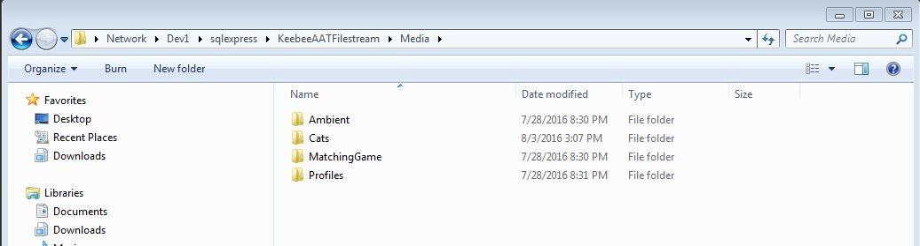

1. Execute the batch file CreateTables.bat (will launch a browser which creates the tables)
2. Execute the batch file SeedData.bat

Install Windows Services

1. Create a shortcut for the batch file *C:\Users\<Username>\Source\Repos\keebee\Script\Service\InstallServices.bat* and place it on your desktop.
2. Create a shortcut for the batch file *C:\Users\<Username>\Source\Repos\keebee\Script\Service\UninstallServices.bat* and place it on your desktop.
3. Execute the batch file (via the shortcut) **InstallServices.bat** with Administrator privileges.

Create Shortcuts

Create a shortcut for the executable: *C:\Users\<Username>\Source\Repos\keebee\UI\Keebee.AAT.Display\bin\****Debug****\Keebee.AAT.Display.exe*

and place it in the top right corner of your primary display (give it the name “Display DEBUG”).

Create a shortcut for the executable:

*C:\Users\\<Username \Source\Repos\keebee\UI\Keebee.AAT.Display\bin\****Release****\Keebee.AAT.Display.exe*

and place it in the top right corner of your primarydisplay (give it the name “Display RELEASE”).

Create a shortcut for the executable:

*C:\Users\\<Username \Source\Repos\keebee\UI\Keebee.AAT.Simulator\bin\Debug\Keebee.AAT.Simulator.exe*

and place it anywhere on your extended display (give it the name “Simulator”).

**NOTE:** It is preferable to use dual monitors as the “Simulator” shortcut needs to be accessible on the extended display. This however only applies when running the Display in RELEASE mode. One monitor is sufficient when running the Display application in DEBUG mode.

**IMPORTANT:** Copy the Flash executables (MatchingGame.swf and SlideViewer.swf) to both the Debug and Release **bin** folders of the application *Keebee.AAT.Display.*

Run the Application

Assuming no errors occurred during any of the above steps throughout this document, the application “Display DEBUG” should now be able to run. It will appear in the top left corner of your primary display.

The “Simulator” can now also be run which will simulate any Phidget interactivity with the display.

Only run “Display RELEASE” if an extended monitor is available. This is because the taskbar will not be available and stopping the application through *Task Manager* will not put it back. The “Simulator” is needed to close the application “nicely” (using the “Kill Display” button)